Detector-Plane Causality in Quantum Measurement:
A Benchmark Framework for Measurement Integrity and Control

Srikar R
Independent Researcher

Abstract

Quantum measurement outcomes are often discussed in terms of observer-dependent collapse or statistical accumulation. In practice, however, quantum experiments rely on complex detector systems whose physical and electronic properties determine which correlations survive measurement.
Here we introduce the Quantum Measurement Stack (QMS), a causally ordered framework that localizes measurement irreversibility at the detector plane, defined as the combined detector material, electronics, firmware, and software pipeline.

We present QMCTB-01, a detector-plane causality benchmark based on a near-field double-slit configuration, demonstrating that interference visibility is determined by detector coherence preservation rather than photon statistics or integration time. Using controlled simulations with shot noise, we show that intensity-only detection irreversibly suppresses interference, while correlation-preserving detection yields stable fringe geometry even at low frame counts.

This work reframes quantum measurement as an instrumentation problem, enabling diagnostics, benchmarking, and control without invoking observer-dependent interpretations.

- Introduction

Quantum interference experiments, particularly the double-slit experiment, have historically been used to illustrate foundational aspects of quantum mechanics. Standard pedagogy often emphasizes the gradual “build-up” of interference patterns through repeated particle detections, implicitly attributing measurement outcomes to statistical accumulation or observation.
Modern quantum experiments, however, depend on sophisticated detector systems comprising sensor materials, analog electronics, digitization pipelines, and software processing. These subsystems are not passive: they determine which correlations are preserved, transformed, or destroyed during measurement.

Despite this, measurement is rarely treated as a structured engineering process. This work addresses that gap by introducing a causal measurement architecture that explicitly localizes irreversibility within the detector pipeline itself.

- The Quantum Measurement Stack

The Quantum Measurement Stack (QMS) decomposes a quantum experiment into a strictly ordered sequence of physical and operational layers:

- Field Excitation and Imprint Formation

- Detector Plane Imaging

- Data Acquisition (DAQ) Integrity

- Quantum Diagnostics

- Quantum Control System (QCS)

The key principle is strict causal ordering: information flows downward, and correlations destroyed at any layer cannot be recovered by higher layers.

Detector Plane Definition

In QMS, the measurement boundary is defined at the detector plane, which includes:

- Detector material (e.g., pixel sensor, photocathode)

- Analog front-end electronics

- Digitization and firmware

- Software readout and reconstruction

Human observation occurs after this boundary and plays no causal role in coherence preservation.

Figure 1 illustrates this decomposition and the localization of measurement irreversibility.

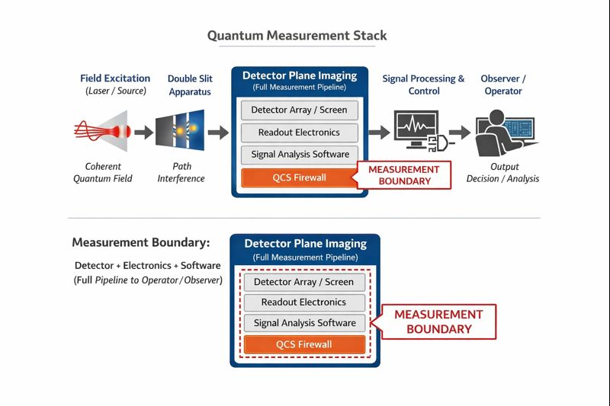

- QMCTB-01: Detector Plane Causality Benchmark

QMCTB-01 is designed to test a single operational question:

Is interference visibility determined by photon statistics, or by detector-plane coherence preservation?

Benchmark Setup
The benchmark models a near-field double-slit configuration under identical excitation and propagation conditions, evaluated under two detector regimes:

- Destroy Mode (Intensity-Only Detection)
Phase information is discarded at the detector plane.

- Preserve Mode (Correlation-Preserving Detection)
Phase correlations are retained through the detector pipeline.

All other parameters are held constant, including shot-noise statistics and frame accumulation.

- Simulation and Diagnostics

The simulation uses paraxial wave optics with Poisson-distributed shot noise to emulate realistic photon detection. Detector behavior is modeled at the measurement plane rather than during post-processing.

Visibility is computed using standard contrast metrics across accumulated frames. Diagnostics are performed without any feedback or adaptive control.
Importantly, no reconstruction or filtering is applied that could artificially recover lost correlations.

- Results

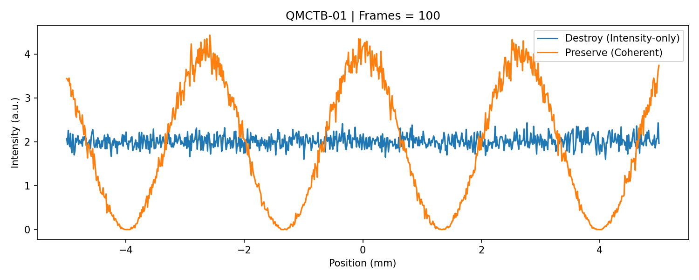
Figure 2 shows representative intensity profiles obtained under the two detector regimes.

In Destroy Mode, interference fringes are absent. As frame count increases, noise averages out, but visibility monotonically decreases toward zero. No amount of integration recovers the fringe geometry.

In Preserve Mode, high-contrast interference fringes are present immediately and remain stable across frame counts. The fringe geometry is fixed early and does not “build up” statistically.

These results demonstrate that interference visibility is determined at the detector plane, not by photon accumulation.

- Implications for Measurement and Control

The benchmark establishes three operational conclusions:

- Measurement irreversibility is localized at the detector plane.

- Interference geometry is a detector property, not a statistical artifact.

- Measurement can be treated as a controllable hardware parameter.

This enables the definition of detector coherence fidelity as a measurable property and motivates the integration of diagnostics and control through a Quantum Control System (QCS).

- Conclusion

QMCTB-01 reframes the quantum-to-classical transition as an instrumentation problem rather than an interpretive one. By explicitly defining the measurement boundary and enforcing causal ordering, the Quantum Measurement Stack provides a practical framework for benchmarking, diagnosing, and controlling quantum measurement systems.

The benchmark is released as open-source software with a DOI-archived reference implementation, enabling reproducibility and extension to experimental platforms.

- Data Availability

The simulation code, benchmark implementation, and reference artifacts are publicly available at:
GitHub: https://github.com/srikarr20/quantum-measurement-stack
DOI: https://doi.org/10.5281/zenodo.17966568

- Figures

Figure 1: Canonical Quantum Measurement Stack and detector-plane causality

Figure 2: QMCTB-01 Detector Plane Causality Benchmark results

